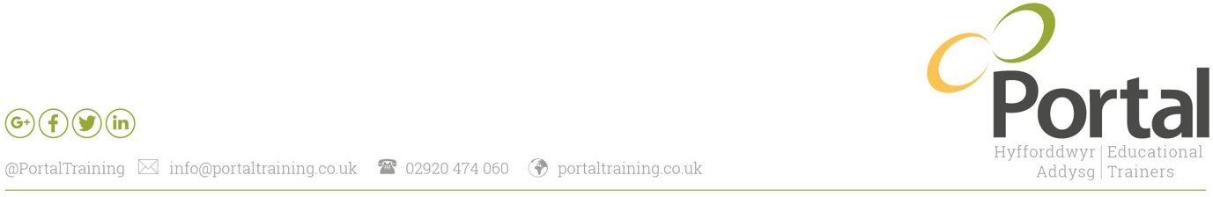
Relations Officer Job Description

Line Manager/responsible to: Relations Manager

Responsible for: NA

Salary banding: 3, £30 – £32K per annum dependent on qualifications held

Summary of Role
To promote, sell and raise awareness of all Portal Training’s products and services to existing and new customers within the regions of South, North, East and West Wales.
Build positive relationships and conduct sales visits to achieve growth and income targets allocated by Relations Manager.
Carry out customer service & impact activities ensuring customer satisfaction and effective employer engagement levels.

Sales and Marketing
- Work in line with sales plans developed and communicated by Relations Manager.
- Actively and positively promote all Portal Training products and services.
- Achieve all agreed and allocated sales targets for WBL recruitment and commercial recruitment/income targets.
- Positively promote Portal Promise enrichments events to achieve desired attendee numbers.
- Identify Head Teachers, CPD Co-ordinators and relevant personnel for all schools within your region to maintain accurate, up to date and compliant databases.
- Attend relevant and agreed conferences and events to positively promote Portal’s products, services and brand to secure new business and raise Portal’s profile.
- Ensure all communication is GDPR compliant in line with Portal’s Information Security Handbook.

Customer Service
- Carryout customer service and impact activities, allocated by Relations Manager, in line with quality assurance processes.
- Respond to and follow up all enquires in a positive, appropriate and timely manner.

Support/Administration
- Support Portal’s Relations Officers to complete all recruitment paperwork and the initial assessment process with learners to an excellent standard when required.
- Support and guide Portal’s Relations Officers to submit all recruitment paperwork in a timely manner in line with claim deadline dates.
- Support Portal’s Relations Officers to ensure that all health and safety vettings and employer contracts are completed prior to completion of learner recruitment paperwork.
- Communicate effectively with Relation Support Officer to ensure a smooth handover to the allocated Assessor.

General Duties
- Update job knowledge by participating in educational opportunities; reading trade publications and attending networking events.
- Take part in any project work deemed necessary by Portal Training’s senior management team.
- Fully engage with and adhere to Portal Training’s company values.
- Embrace Portal Training’s strategies, polices and processes.
- Ensure that all your practices adhere to information security policies, procedures and legislation.
- Work as a team to ensure continuous quality improvements supporting the company’s journey to excellence.
- Keep outlook calendars up to date at all times.
Key Responsibilities: The above duties are not an exhaustive list and should be viewed as guidance. Your line manager or Portal’s Senior Management team may ask that you take part in additional duties in order to fully utilise your experience, skills and knowledge.

Key Performance Indicators
Measure | QA Activity | Performance Indicators
Core Values | Demonstrate core values | (RAG) Green
Sales | Achieve all agreed monthly contract targets | 90%
Customer Service | Carry out all agreed impact/customer service activities | 100%
Data | Accurately log leads & starts information, in line with GDPR, to inform enrolments | 100%

Personal Qualities
- Excellent rapport building and people skills.
- Excellent communication skills both verbal and written.
- A personable person with a proven track record of working with a diverse range of individuals.
- A highly self motivated individual with a positive ‘can do’ attitude.
- A proven track record in effective interdepartmental relationships.
- Excellent time management.

Essential Experience and Skills
- Excellent communication skills, both verbal and written.
- Experience of working within a school setting.
- The ability to research to stay abreast of current educational matters.
- Experience in delivering presentations.
- A proven track record in forging and maintain excellent working relationships.

Desirable Experience and Skills
- Experience in working successfully in a sales role.
- ILM Level 5 Leadership and Management qualifications.

Portal Values

